**Project Report**

**On**

**Online Discussion Forum**

Submitted by: Olando Charlton

**INTRODUCTION**

This website “ONLINE DISCUSSION FORUM” is made for providing a platform for having discussions. This forum provides the platform under one roof to interact with different members which maybe the experts in a particular field or a normal employee for seeking or to give advices. Anonline space on which anybody can have discussions regarding any research, academic documents or any latest technology free of cost. A website which helps to resolve doubts, queries related to any field by having discussions with other registered users.

**INDEX**

**1. Introduction**

1.1 Problem Definition.

1.2 Feasibility Study.

1.3 Objective of the project.

**2. System Requirement and Specifications**

2.1 Hardware Requirement.

2.2 Software Requirement.

2.3 Manpower Requirement.

**3. About Modules**

3.1 Admin Module

3.2 Registration Module

3.3 Profile Management Module

3.4 Discussion Module.

**4. Platform of implementation**

Detailed description about the technology.

**5. Data Flow Diagram**

5.1 Data Flow Diagram.

5.2 ER Diagram.

**6. Conclusion**

**7. Screenshot**

**PROBLEM DOMAIN**

With highly growing of the telecommunication infrastructures, such as Internet and the development of the high performance have brought about new era of rapid advances in information technology. Internet has become an ocean of information related to every aspect which has existence in this world. The main purpose of this website is to develop a one roof platform for the effective interaction, effective exposure, and a right direction toward communication. My aim is to provide our users an opportunity to enhance their knowledge by sharing their views on this platform by having discussions with other users. The intended audience is spiritual and higher knowledge users. This website will act as a healthy questionnaire which helps to give and get effective solutions with best of their experience.

**OBJECTIVE OF THE PROJECT**

I put my complete effort in order to provide a complete solution to the target users under one roof. It is a website of its own kind that provides a ceramic way to attain and give knowledge. Here the process of knowledge sharing is concerned with the purity of the facts and figures collected from various authentic sources. My aim is to help the passionate people to share their views with its purity and trueness. These different users can guide each other on various aspects. Beyond this my website will give the opportunity to every user say “a lot of eminent personalities within the institute who can share their

bright knowledge over the website”. Last but not the least this website also gives the opportunity to the employees for sharing of knowledge and for utilization of the efforts by gaining the knowledge.

**System Requirement** **and Specifications**

**HARDWARE REQUIREMENT**

This section will describe the hardware requirement which is at least necessary to run this website.

**Processor**

The minimum requirement of processor is at least Pentium IV with900 MHz processing speed. The speed of processor determines the time taken for the execution of the instructions. Higher processing speed leads to faster execution of the instruction.

**RAM**

There should be minimum 256 MB of RAM available for the smooth functioning of the project. Higher memory leads in better results.

**Hard disk**

There should be about minimum 40GB of hard disk for smooth functioning of the project and so the recommended hard disk space is 40GB.

**Cache Memory**

There must be about 512 KB of cache memory so that the accessing time can be better and compilation is easier.

**SOFTWARE REQUIREMENT**

**Operating System**

Window XP, 7, 8 and other operating systems like Linux; MacOS can also be used since .Net is platform independent.

**Programming Language**

PHP, HTML, CSS

**Web Technology**

.NET FRAMEWORK, PHP FRAMEWORK

**Back End**

SQL Server, Laravel 9

**Packages**

Laravel Framework

Laravel Jetstream

Laravel Livewire

Laravel Sanctum

Blade-ui-kit

**About Modules**

**Admin Module**

“This is a Master Creation Module. It will look after and control all the discussions being created and posted. Once the discussions are created and posted the admin has the authority to see and alter those discussions.”

**Registration Module**

“This module is responsible for the registration of a new user. In this module the user register’s itself by entering the required information. This module also verifies the new user details with the previously registered users.”

**Profile Management Module**

“This module manages the profiles of all the registered users. In this module all the details of the registered users are stored. It creates a separate record for individual users about all the discussion being created and posted.”

**Discussion Module**

“This module manages the discussions created by the corresponding users.

It helps the user to have discussions with each other. This module helps in

managing all the discussions amongst different users.”

**Data Flow Diagram**

**Data Flow Diagram**

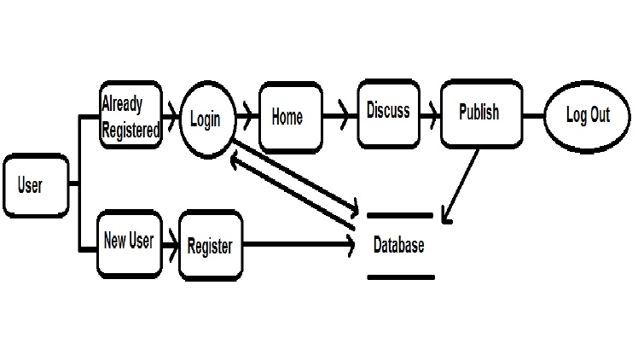

**Conclusion (Future Scope and References)**

Future Scope:

“This Forum can easily support any browser. Various updates can be performed in this forum in coming future. This forum willresult in minimizing the gap amongst different users. This forum gives a platform which results in an easy way of communication amongst different people from different areas”.

**Screen Shots**